**Business Plan of (Brain Boost) Healthy Food Company**

**Students:**

**Ahmed Abdelazim Hassan 202000772**

**Marwan Maged 211000328**

**Abdalrhman Zenhom 202002587**

**Submitted to English Department**

**Dr. Nada Osama**

**Nile University**

Table of Contents

Executive summary 3

Company Overview 4

Market and Competitive Analysis: 5

Growth Trends and Key Driving Forces: 5

Key Characteristics and Needs of the Target Market: 5

• The target market for Brain Boost includes individuals who are still studying, ranging from the age of 7 and onwards. 5

• Students have a need for nutritious and convenient food options that support their cognitive function, concentration, and overall well-being. 5

• They seek food choices that are not only healthy but also appealing in taste and easily accessible within their educational environments. 5

Market Acceptance for the Product or Service: 5

Marketing Mix 6

Management Team: 7

Operating Strategies: 9

Marketing Strategy: 9

Production Strategy: 9

Research and Development Strategy: 9

Personnel Strategy: 9

Administrative Strategy: 10

SWOT Analysis: 10

**Investment Opportunity:** 11

**Funding** 11

**Costs** 11

**Timeline** 12

# Executive summary

**Overview:**

BrainBoost is dedicated to providing college students with a wide range of healthy vegan food options. Our mission is to offer convenient and nutritious plant-based meals and snacks that support students' well-being and academic success. This business plan outlines our market analysis, marketing strategies, implementation plan, financial projections, and future plans.

**Mission:**

Our mission is to provide a reasonable sum of money to support a healthy lifestyle for college students. We believe that nourishing their bodies with nutritious vegan food will enhance their overall well-being and academic performance.

**Vision:**

We aim to revolutionize the college dining experience by providing convenient and nutritious vegan food options. Our vision is to inspire and empower students to make conscious dietary choices that prioritize their health, the environment, and animal welfare.

# Company Overview

* **Vision**: To revolutionize the way students eat and prioritize their health by providing fresh and nutritious food options that support their focus and well-being.
* **History**: Brain Boost was founded with the mission to address the lack of healthy eating options for students. It was established by a team of passionate individuals who recognized the importance of nutrition in academic success.
* **Current Status**: Brain Boost is in the early stages of development, with products already formulated and ready for production. The company has conducted market research, established key partnerships, and gained positive feedback from potential customers.

**Goals:**

1. To become the go-to brand for fresh and healthy food options among students.
2. To expand the availability of Brain Boost products in nurseries, schools, universities, and clubs.
3. To continually innovate and introduce new products that cater to the evolving needs and preferences of the target market.

**Objectives:**

1. To establish a strong brand presence and build trust among students, parents, and educational institutions.
2. To ensure the highest quality standards by obtaining all necessary certifications and partnering with reputable suppliers.
3. To create a positive impact on students' health and overall lifestyle choices through education and awareness campaigns.

# Market and Competitive Analysis:

Growth Trends and Key Driving Forces:

* The market for healthy eating and wellness has been experiencing significant growth, driven by increasing consumer awareness and interest in maintaining a healthy lifestyle.
* Growing concerns about nutrition and the impact of diet on overall well-being have created a demand for fresh and healthy food options.
* Increasing focus on mental and cognitive health among students has led to a greater emphasis on nutrition for improved focus and academic performance.

Key Characteristics and Needs of the Target Market:

## The target market for Brain Boost includes individuals who are still studying, ranging from the age of 7 and onwards.

## Students have a need for nutritious and convenient food options that support their cognitive function, concentration, and overall well-being.

## They seek food choices that are not only healthy but also appealing in taste and easily accessible within their educational environments.

Competitive Environment:

* The market for healthy food options is competitive, with both established players and new entrants offering a range of products targeting the student demographic.
* Competitors may include local and national food suppliers, catering services, and health-focused food brands.
* Differentiation through quality, taste, convenience, and understanding the specific needs of the student market will be essential for success.

Market Acceptance for the Product or Service:

* The increasing emphasis on healthy eating and the benefits of nutrition for cognitive function creates a favorable environment for Brain Boost's offerings.
* Market research and feedback from potential customers indicate a positive response and demand for fresh, healthy food options that specifically cater to students' needs.
* Early partnerships with educational institutions and positive customer testimonials contribute to market acceptance and validate the value proposition of Brain Boost.

Marketing Mix

* **Product**:

1. **Sandwiches** (Oat-Vegan Based): Nutritious and flavorful sandwiches made with oat-vegan ingredients. Ready for production, offering a unique and healthy meal option for students.
2. **Waffles** (Oat-Vegan Based): Wholesome waffles made with oat-vegan ingredients. Ready for production, offering a nutritious and convenient breakfast or snack option for students.
3. **Pasta**: Nutritious pasta made with high-quality ingredients. Ready for production, providing a versatile and filling meal option for students.
4. **Juices**: Fresh and natural juices packed with vitamins and nutrients. Ready for production, offering a refreshing and healthy beverage option for students.
5. **Salads**: Fresh and vibrant salads with a variety of ingredients. Ready for production, providing a nutritious and light meal option for students.
6. **Protein** **Bars**: Nutrient-dense bars with a balanced combination of proteins and other essential ingredients. Ready for production, offering a convenient and energizing snack option for students

And more later on after the opening..

* **Price**: Brain Boost aims to provide its products at a competitive price point that offers value to customers. The pricing strategy takes into account the quality of ingredients, the cost of production, and the target market's affordability.
* salads - 25-60 EGP  
  Sandwiches: 30- 60 EGP  
  Juices: 15-40 EGP  
  Pasta: 50-80 EGP  
  Waffles: 15-30 EGP  
  Protein Bars: 25-55 EGP
* **Place**: Brain Boost ensures its products are readily available to its target market. It establishes strategic partnerships with schools, universities, studying centers, and clubs to offer its products on-site. Additionally, Brain Boost provides the convenience of online ordering and delivery vans to cater to the busy lifestyles of students.
* **Promotion**: Brain Boost adopts a multi-faceted promotional approach to create awareness and drive demand for its products. It leverages various channels such as social media, digital marketing, targeted advertising, and collaborations with student organizations. The promotional efforts highlight the benefits of Brain Boost's products in improving focus and supporting a healthy lifestyle.

# Management Team:

* Ahmed Abdelazim Hassan (Founder and Director): Ahmed is a visionary leader with a strong background in business administration. He is passionate about promoting healthy eating habits among students and has the drive to steer Brain Boost towards success.
* Marwan Maged (CEO): Marwan brings valuable expertise in food production and operations management. With a track record of ensuring efficient processes and high-quality standards, he plays a crucial role in overseeing the day-to-day operations of the company.
* Abdalrhman Zenhom (Head of Marketing): Abdalrhman is a marketing expert who possesses a deep understanding of the target market. He develops and implements strategic marketing initiatives to build brand awareness, attract customers, and drive sales.

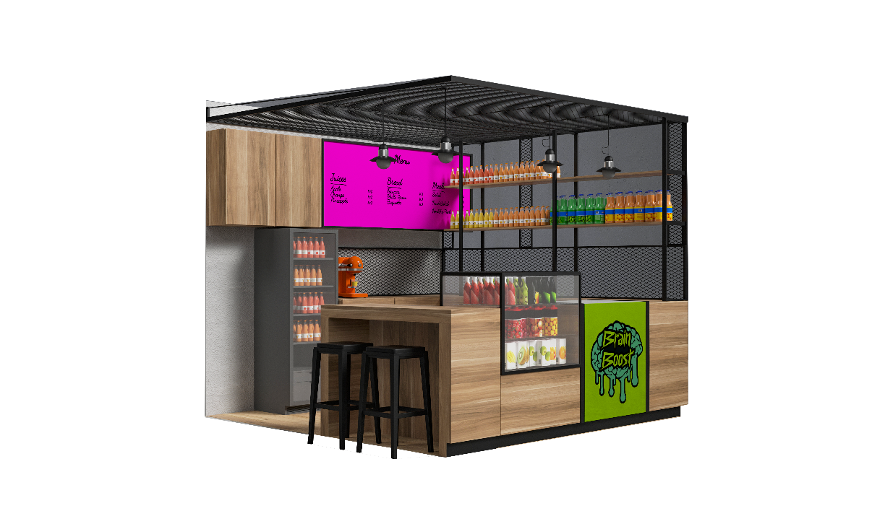The management team of Ahmed, Marwan, and Abdalrhman works synergistically to ensure the effective functioning of Brain Boost. Their diverse backgrounds and skill sets contribute to the company's growth and success. As the business expands, additional personnel needs may arise in areas such as production, distribution, and customer service. The organizational structure currently follows a hierarchical model, with the management team overseeing various departments and teams to ensure smooth operations and achieve the company's objectives.

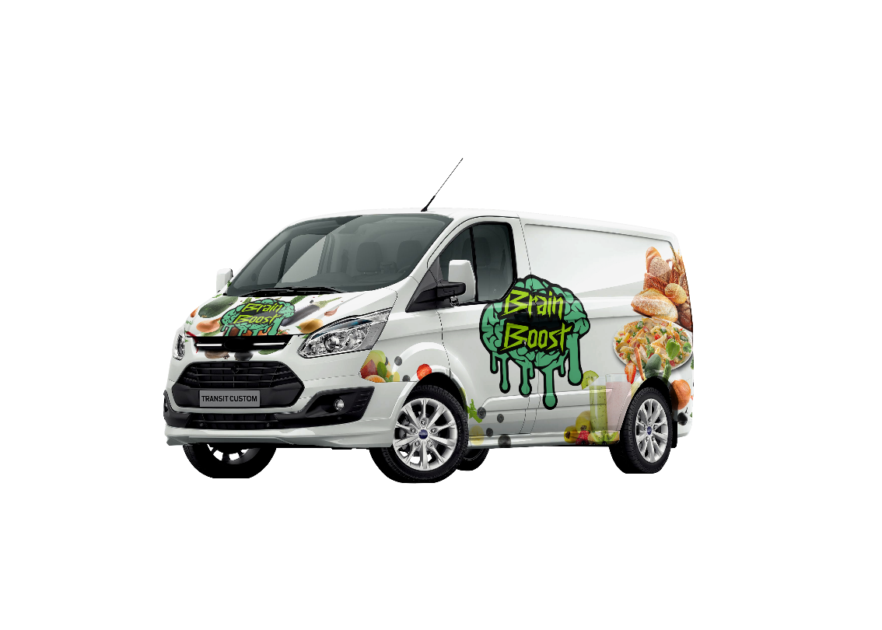

# Operating Strategies:

### Marketing Strategy:

* Targeting the student population through effective marketing channels such as social media, university partnerships, and targeted advertising campaigns.
* Highlighting the health benefits and convenience of Brain Boost's products to attract and engage the target market.
* Utilizing market research to understand consumer preferences and adapt marketing strategies accordingly.

### Production Strategy:

* Ensuring efficient production processes to meet the demand for Brain Boost's products.
* Sourcing high-quality ingredients from reputable suppliers to maintain product quality and freshness.
* Implementing quality control measures to ensure consistency and adherence to food safety standards.

### Research and Development Strategy:

* Continuously innovating and expanding the product range to cater to evolving consumer preferences and dietary needs.
* Conducting research on emerging food trends, nutritional advancements, and customer feedback to inform product development decisions.

### Personnel Strategy:

* Hiring skilled and dedicated employees who align with the company's values and vision.
* Providing ongoing training and development opportunities to enhance employee knowledge and skills.
* Fostering a positive and inclusive work environment that encourages teamwork and collaboration.

### Administrative Strategy:

* Implementing effective systems and processes to streamline administrative tasks and ensure smooth operations.
* Establishing clear communication channels within the organization to facilitate efficient decision-making and problem-solving.

# SWOT Analysis:

**Strengths**:

* Specialization in fresh healthy eating, catering to the growing demand for nutritious food options.
* Targeting the student population, a specific and potentially profitable market segment.
* Trusted by customers, emphasizing the company's reputation for quality and honesty.
* Focus on creating sound minds and supporting academic success through healthy eating.

**Weaknesses**:

* Lack of information on the proprietary position and competitive advantages of the products.
* Potential challenges in sourcing high-quality ingredients consistently.
* Limited details on the company's manufacturing process and quality certificates.

**Opportunities**:

* Growing interest in healthy eating and plant-based diets among the target market.
* Availability of places such as nurseries, schools, universities, and clubs to expand the customer base.
* Potential partnerships with educational institutions to promote and sell Brain Boost's products.

**Threats**:

* Intense competition in the healthy food industry.
* Changing consumer preferences and dietary trends.
* Potential legal and regulatory challenges related to food safety and certifications.

**Contingency Plans:**

* Conduct thorough market research and stay updated on consumer trends to adapt the product offerings accordingly.
* Establish strategic partnerships and collaborations to expand the distribution network and reach a wider customer base.
* Continuously monitor and address any potential legal and regulatory issues to ensure compliance and maintain a positive reputation.

# **Investment Opportunity:**

Brain Boost presents a compelling investment opportunity in the growing market of healthy food for students. With its unique business model, strong focus on quality and nutrition, and targeted approach to the student population, Brain Boost has the potential to capture a significant share of the market. The company's clear vision, experienced management team, and commitment to integrity make it an attractive investment for those seeking to participate in the thriving health food industry.

## **Funding**

Brain Boost requires funds to support various aspects of the venture. The following outlines the key details of the funding required:

Amount: The total funding needed for the startup is 1,182,000EGP for 20% Equity

Timing: The funds will be required at the start of the venture to cover initial setup costs for 1 year

Use of Funds: The funds will be utilized for the following purposes:

## **Costs**

The startup will require approximately 1.2 million EGP in its first year. Our goal as a startup is to break even by the end of the first year and profit by the end of the second. The first year's expenses will be divided as follows:

## **Timeline**

**Thanks.**